**ASSIGNMENT 1-THE CASE OF 50 STARTUPS**

VISUALIZATION OF DATA:

1.EXPLORE DATA RELATIONSHIPS

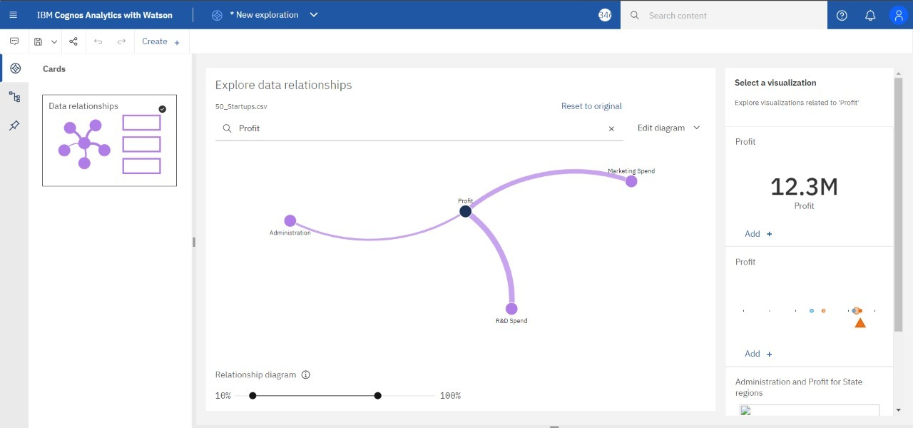

2.PROFIT

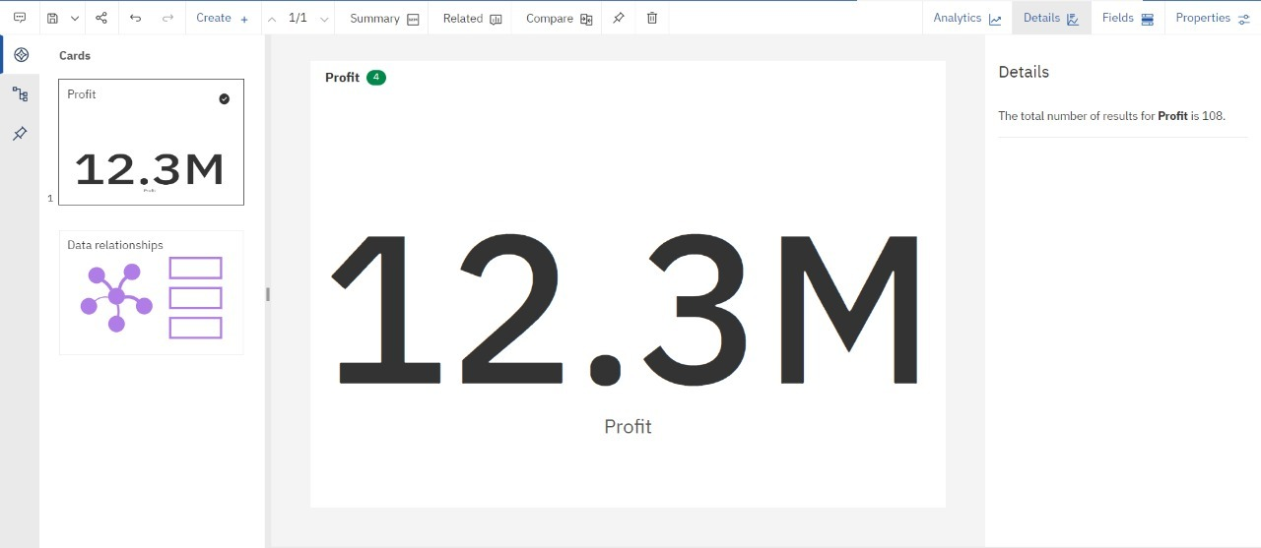

3.PROFIT,R&D SPEND EXPLORATION

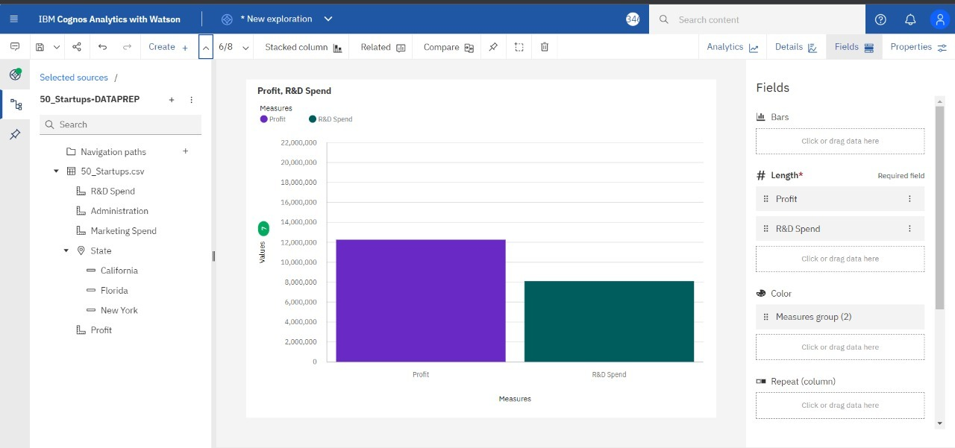

4.PROFIT,ADMINISTRATION SPEND

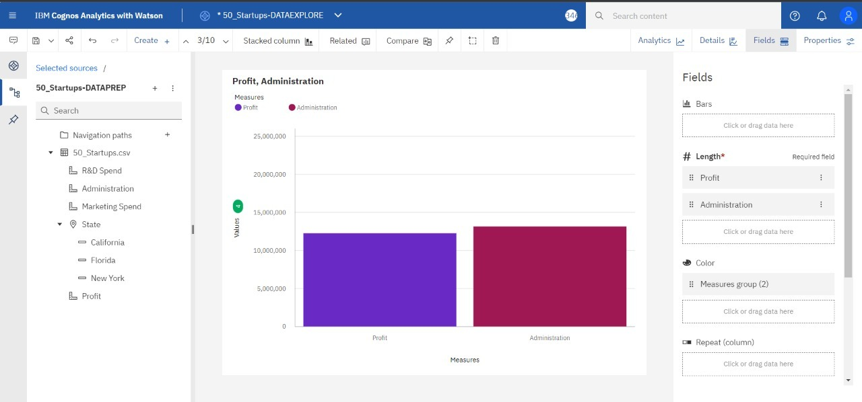

5.PROFIT,MARKETING SPEND

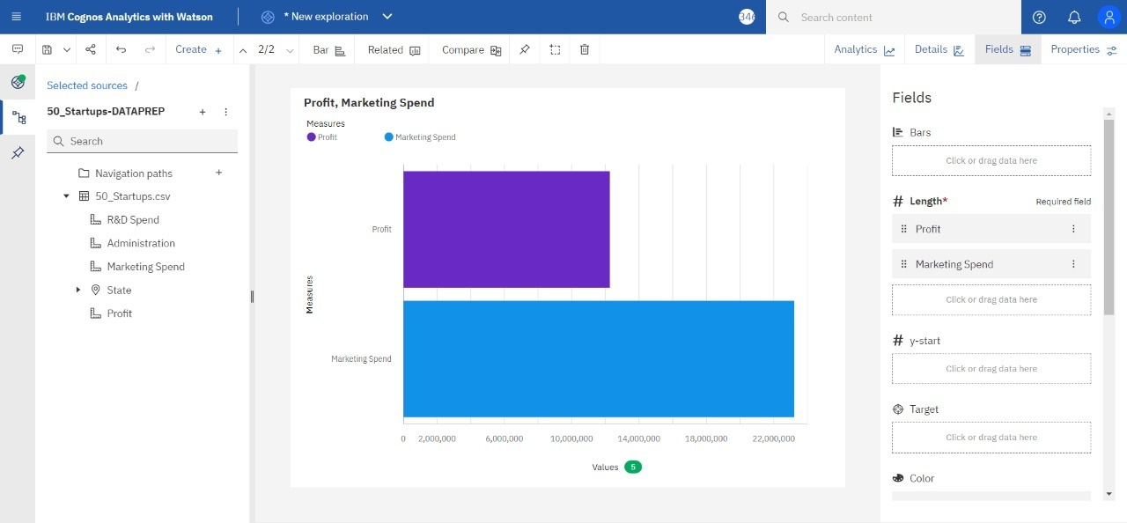

6.PROFIT BY STATE

